Elite Series Battery
The Next Generation Battery Technology

- Full Four Year Warranty  These are the only batteries to offer a full four year warranty. A three year warranty has been industry standard for a long-lasting battery... so, we completely redesigned our batteries to last an additional year. | - More Amp Hours  Keeping the same industry dimensions for each battery type, we designed this series to have more power. This keeps your equipment/ electronics running longer. | Additional Features  - Flame Retardant Case  - Designed for Long Life  - Full Four Year Warranty  - Planet Friendly Materials  - Sealed Maintenance Free  - Vibration Resistant Design  - Carrying Handles Included  - Can be Installed in any Position  (Except upside down)

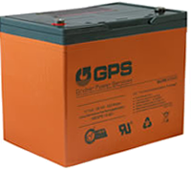  6 Volt, 200AH  58EGPS-6-200-I | 12 Volt, 26AH  58EGPS-12-26-P | 12 Volt, 35AH  58EGPS-12-35-P | 12 Volt, 55AH  58EGPS-12-55-I
12 Volt, 80AH  58EGPS-12-80-I | 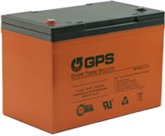  12 Volt, 93AH  58EGPS-12-93-I | 12 Volt, 103AH  58EGPS-12-103-I | 12 Volt, 118AH  58EGPS-12-118-I
 | 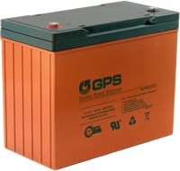  12 Volt, 140AH  58EGPS-12-140I | 12 Volt, 150AH  58EGPS-12-150-I

