Elite Series Battery
The Next Generation Battery Technology

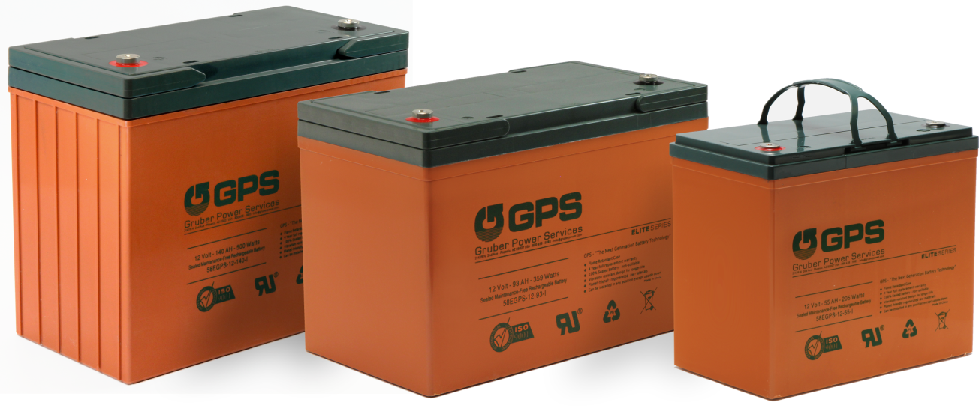

- Full Four Year Warranty  These are the only batteries to offer a full four year warranty. A three year warranty has been industry standard for long-lasting batteries... so, we completely redesigned our batteries to last an additional year. | - More Amp Hours  Keeping the same industry dimensions for each battery type, we designed this series to have more power. This keeps your equipment/ electronics running longer. | Additional Features  - Flame Retardant Case  - Designed for Long Life  - Full Four Year Warranty  - Planet Friendly Materials  - Sealed Maintenance Free  - Vibration Resistant Design  - Carrying Handles Included  - Can be Installed in any Position  (Except upside down)

 |  |  | Watts Per Cell at 77°F (25°C)
 |  |  | Operating Time (in minutes) to 1.67 Volts Cell |  |  |  |  |  |  |  |  |  | Weight | Model
Volts | Amps | Watts | 5 | 10 | 15 | 20 | 25 | 30 | 45 | 60 | 5hr | 20hr | lbs | #
6 | 200 | 644.1 | 1022 | 779 | 644 | 543 | 473 | 419 | 314 | 250 | 69.6 | 21.4 | 65.0 | 6-200-I
12 | 26 | 92.5 | 175 | 119 | 92 | 76 | 65 | 58 | 43 | 35 | 9.72 | 2.86 | 20.9 | 12-26-I
12 | 35 | 149.6 | 294 | 197 | 149 | 122 | 104 | 90 | 65 | 51 | 12.9 | 3.82 | 23.8 | 12-35-I
12 | 55 | 225.1 | 406 | 274 | 225 | 183 | 157 | 131 | 93 | 74 | 19 | 5.9 | 38.1 | 12-55-I
12 | 80 | 302.0 | 548 | 395 | 302 | 247 | 214 | 188 | 138 | 110 | 29 | 8.73 | 55.0 | 12-80-I
12 | 93 | 370.0 | 600 | 457 | 370 | 304 | 276 | 223 | 160 | 127 | 34.4 | 10.2 | 59.5 | 12-93-I
12 | 103 | 430.0 | 678 | 518 | 430 | 356 | 308 | 260 | 186 | 148 | 39.2 | 11.8 | 68.8 | 12-103-I
12 | 118 | Coming Soon |  |  |  |  |  |  |  |  |  |  |  | 12-118-I
12 | 140 | 499.5 | 804 | 620 | 499 | 421 | 365 | 321 | 238 | 191 | 51 | 15 | 97.4 | 12-140-I
12 | 150 | Coming Soon |  |  |  |  |  |  |  |  |  |  |  | 12-150-I

